NAAN MUDHALVAN – ARTIFICIAL INTELLIGENCE

HOUSE PRICE PREDICTION USING MACHINE LEARNING

## *A PROJECT REPORT*

## Submitted by

|  |  |  |
| --- | --- | --- |
| **MURUGAN M** | - **III CSE ‘B’** | **(610521104056)** |
| **MONIKA S** | - **III CSE ‘B’** | **(610521104055)** |
| **YUVARAJ M** | - **III CSE ‘B’** | **(610521104104)** |
| **SATHESH PC** | - **III CSE ‘B’** | **(610520104082)** |

**RAHUL GANESH B -III CSE ‘B’ (610521104306)**

BACHELOR OF ENGINEERING

in

**COMPUTER SCIENCE AND ENGINEERING**

DHIRAJLAL GANDHI COLLEGE OF TECHNOLOGY SALEM - 636 309



**ANNA UNIVERSITY :: CHENNAI 600 025**

**NOVEMBER 2023**

## NAAN MUDHALVAN – ARTIFICIAL INTELLIGENCE

**AI ENABLED CAR PARKING USING OPEN CV**

## *A PROJECT REPORT*

### Submitted by

|  |  |  |
| --- | --- | --- |
| **MURUGAN M** | - **III CSE ‘B’** | **(610521104056)** |
| **MONIKA S** | - **III CSE ‘B’** | **(610521104055)** |
| **YUVARAJ M** | - **III CSE ‘B’** | **(610521104104)** |
| **SATHESH PC** | - **III CSE ‘B’** | **(610520104082)** |

**RAHUL GANESH B -III CSE ‘B’ (610521104306)**

BACHELOR OF ENGINEERING

in

**COMPUTER SCIENCE AND ENGINEERING**

DHIRAJLAL GANDHI COLLEGE TECHNOLOGY SALEM - 636 309

**ANNA UNIVERSITY :: CHENNAI 600 025**

**NOVEMBER 2023**

**BONAFIDE CERTIFICATE**

Certified that this project report **“AI ENABLED CAR PARKING USING OPEN CV IN ARTIFICIAL INTELLIGENCE”** is the bonafide work of

MURUGAN M (610521104056), MONIKA S (610521104055), YUVARAJ M (610521104104), SATHESH PC (610520104082), RAHUL GANESH B (610521104306) who carried out the work under my supervision.



Phase 5 submission document

|  |  |
| --- | --- |
| DATE | 31-10-2023 |
| TEAM ID / TEAM NAME | Proj_224021_Team_1 |
| PROJECT NAME | PREDICTION HOUSE PRICE USING MACHINE LEARNING |
| STUDENT NAME WITH ID | Murugan M - au610521104056  Monika S - au610521104055  Yuvaraj M - au610521104102  Sathesh PC - au610521104082  Rahul Ganesh B - au610521104306 |

Introduction:

The real estate market is a dynamic and complex arena, where property values can fluctuate significantly due to a multitude of factors. For both homebuyers and sellers, accurately determining the fair market value of a property is of paramount importance.

In this era of technological advancement, machine learning has emerged as a game-changing tool in the realm of real estate. One of its most compelling applications is predicting house prices with remarkable accuracy.

Traditional methods of property valuation, relying on factors such as location, square footage, and recent sales data, are undoubtedly useful. However, they often fall short in capturing the intricacies and nuances that drive real estate market dynamics.

Machine learning, on the other hand, has the capability to process vast volumes of data and identify patterns that human appraisers might overlook. This technology has the potential to revolutionize the way we value real estate, offering more precise and data-driven predictions.

In this exploration, we delve into the exciting world of predicting house prices using machine learning. We will uncover how this cutting-edge technology harnesses the power of algorithms and data to create predictive models that consider an array of variables, such as neighborhood characteristics, property features, economic indicators, and even social trends.

By doing so, machine learning enables us to make informed, databacked predictions about the future value of a property. This transformation of the real estate industry is not only beneficial for buyers and sellers but also for investors, developers, and policymakers. Accurate house price predictions can inform investment decisions, urban planning, and housing policy development, leading to a more efficient and equitable real estate market.

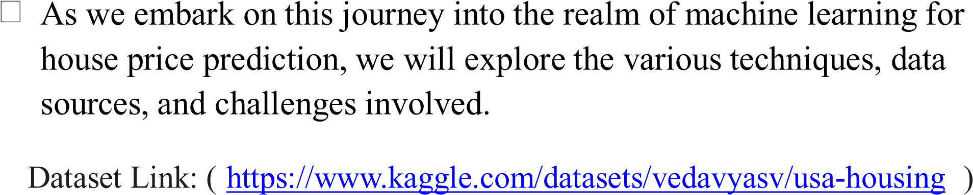

5000

Rows x 7 Columns

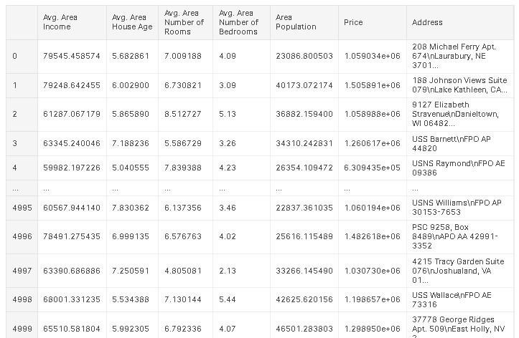

Here's a list of tools and software commonly used in the

process:

**1. Programming Language:**

- Python is the most popular language for machine learning due to

its extensive libraries and frameworks. You can use libraries like NumPy,pandas, scikit-learn, and more.

**2. Integrated Development Environment (IDE):**

- Choose an IDE for coding and running machine learning

experiments. Some popular options include Jupyter Notebook, Google

Colab, or traditional IDEs like PyCharm.

**3. Machine Learning Libraries:**

- You'll need various machine learning libraries, including:

- scikit-learn for building and evaluating machine learning models.

- TensorFlow or PyTorch for deep learning, if needed.

- XGBoost, LightGBM, or CatBoost for gradient boosting models.

**4. Data Visualization Tools:**

- Tools like Matplotlib, Seaborn, or Plotly are essential for data

exploration and visualization.

**5. Data Preprocessing Tools**:

- Libraries like pandas help with data cleaning, manipulation, and

preprocessing.

6. Data Collection and Storage:

- Depending on your data source, you might need web scraping

tools (e.g., BeautifulSoup or Scrapy) or databases (e.g., SQLite,

PostgreSQL) for data storage.

**7. Version Control:**

- Version control systems like Git are valuable for tracking

changes in your code and collaborating with others.

**8. Notebooks and Documentation:**

- Tools for documenting your work, such as Jupyter Notebooks

or Markdown for creating README files and documentation.

**9. Hyperparameter Tuning:**

- Tools like GridSearchCV or RandomizedSearchCV from

scikit-learn can help with hyperparameter tuning.

**10. Web Development Tools (for Deployment):**

- If you plan to create a web application for model deployment,

knowledge of web development tools like Flask or Django for backend development, and HTML, CSS, and JavaScript for the front-end can be

useful.

**11. Cloud Services (for Scalability):**

- For large-scale applications, cloud platforms like AWS, Google

Cloud, or Azure can provide scalable computing and storage resources.

**12. External Data Sources (if applicable):**

- Depending on your project's scope, you might require tools to

access external data sources, such as APIs or data scraping tools.

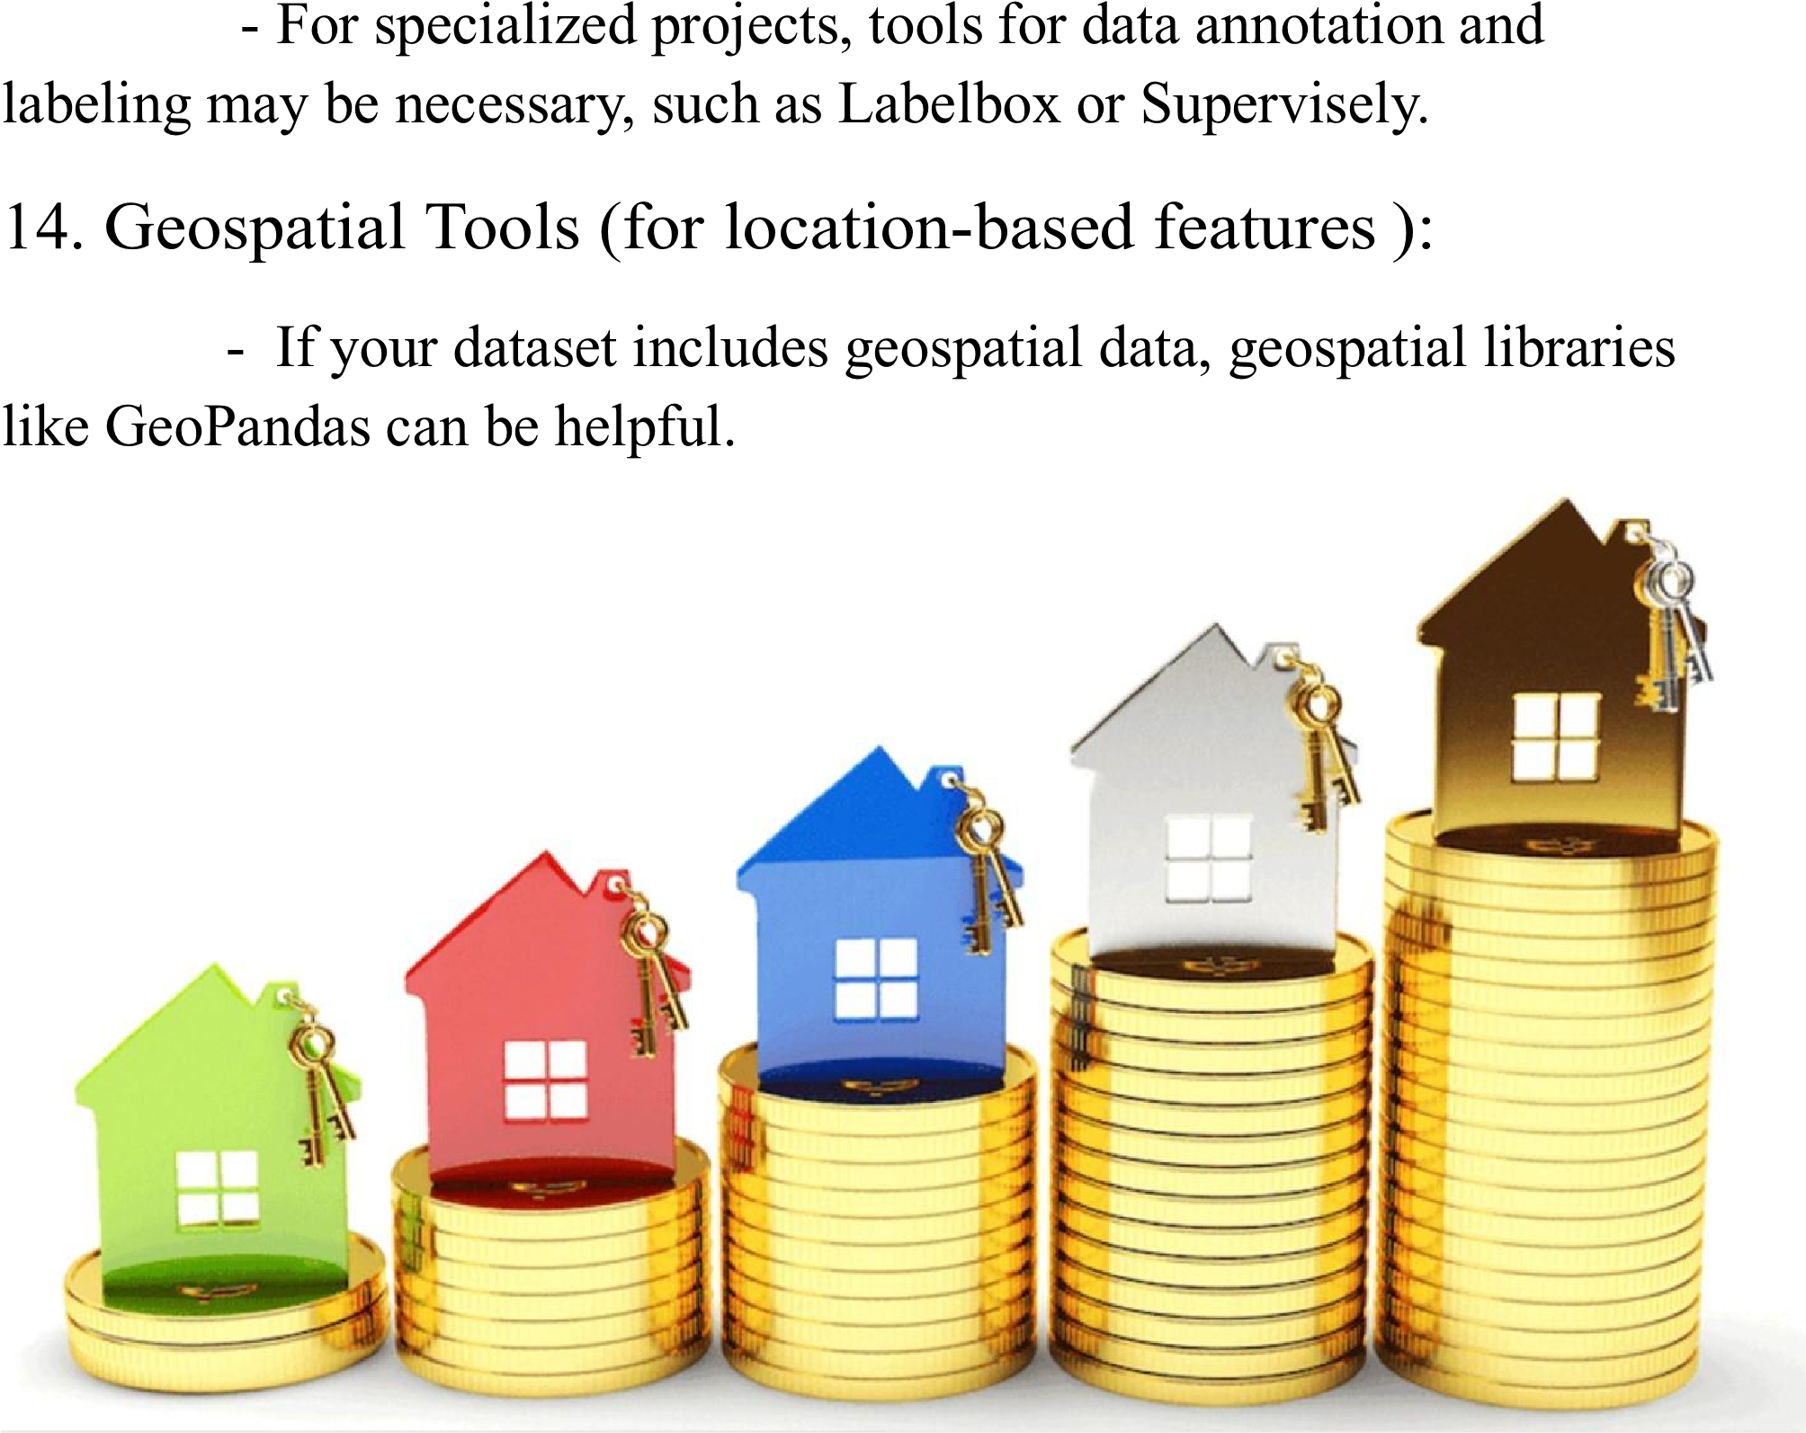**13. Data Annotation and Labeling Tools (if applicable):**

1.DESIGN THINKING AND PRESENT IN FORM

OF DOCUMENT

**1.Empathize:**

➢ Understand the needs and challenges of all stakeholders involve in

the house price prediction process, including homebuyers, sellers,

real estate professionals, appraisers, and investors

➢ Conduct interviews and surveys to gather insights on what users

value in property valuation and what information is most critical for

their decision-making.

**2.Define**:

➢ Clearly articulate the problem statement, such as "How might we

predict house prices more accurately and transparently using machine learning?"

➢ Identify the key goals and success criteria for the project, such as

increasing prediction accuracy, reducing bias, or improving user trust

in the valuation process.

**3.Ideate:**

➢ Brainstorm creative solutions and data sources that can enhance the accuracy and transparency of house price predictions.

➢ Encourage interdisciplinary collaboration to generate a wide range of ideas, including the use of alternative data, new algorithms, or

improved visualization techniques.

**4.Prototype:**

➢ Create prototype machine learning models based on the ideas

generated during the ideation phase.

➢ Test and iterate on these prototypes to determine which approaches

are most promising in terms of accuracy and usability.

**5.Test**:

➢ Gather feedback from users and stakeholders by testing the machine

learning models with real-world data and scenarios.

➢ Assess how well the models meet the defined goals and success

criteria, and make adjustments based on user feedback.

**6.Implement:**

➢ Develop a production-ready machine learning solution for predicting

house prices, integrating the best-performing algorithms and data

sources.

➢ Implement transparency measures, such as model interpretability

tools, to ensure users understand how predictions are generated.

**7.Evaluate:**

➢ Continuously monitor the performance of the machine learning

model after implementation to ensure it remains accurate and

relevant in a changing real estate market.

➢ Gather feedback and insights from users to identify areas for

improvement.

**8.Iterate:**

➢ Apply an iterative approach to refine the machine learning model

based on ongoing feedback and changing user needs.

➢ Continuously seek ways to enhance prediction accuracy,

transparency, and user satisfaction.

**9.Scale and Deploy:**

➢ Once the machine learning model has been optimized and validated, deploy it at scale to serve a broader audience, such as real estate professionals, investors, and homeowners.

➢ Ensure the model is accessible through user-friendly interfaces and integrates seamlessly into real estate workflows.

**10.Educate and Train:**

➢ Provide training and educational resources to help users understand how the machine learning model works, what factors it considers, and its limitations.

➢ Foster a culture of data literacy among stakeholders to enhance trust in the technology.

**2.DESIGN INTO INNOVATION**

**1. Data Collection:**

Gather a comprehensive dataset that includes features such as

location, size, age, amenities, nearby schools, crime rates, and other

relevant variables

.

**2. Data Preprocessing:**

Clean the data by handling missing values, outliers, and

encoding categorical variables. Standardize or normalize numerical

features as necessary.

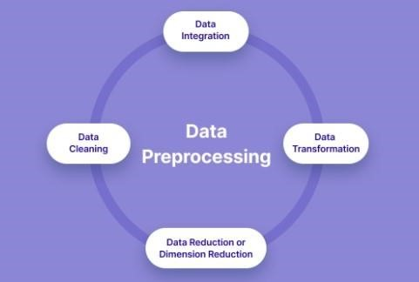

**PYHON PROGRAM**:

# Import necessary libraries

import pandas as pd

from sklearn.preprocessing import LabelEncoder

from sklearn.model_selection import train_test_split

from sklearn.impute import SimpleImputer

from sklearn.preprocessing import StandardScaler

# Load the dataset (replace 'house_data.csv' with your dataset file)

data = pd.read_csv('E:/USA_Housing.csv')

# Display the first few rows of the dataset to get an overview

print("Dataset Preview:")

print(data.head())

**# Data Pre-processing**

# Handle Missing Values

# Let's fill missing values in numeric columns with the mean and in

categorical columns with the most frequent value.

numeric_cols = data.select_dtypes(include='number').columns

categorical_cols = data.select_dtypes(exclude='number').columns

imputer_numeric = SimpleImputer(strategy='mean')

imputer_categorical = SimpleImputer(strategy='most_frequent')

data[numeric_cols] =

imputer_numeric.fit_transform(data[numeric_cols])

data[categorical_cols] =

imputer_categorical.fit_transform(data[categorical_cols])

# Convert Categorical Features to Numerical

# We'll use Label Encoding for simplicity here. You can also use onehot encoding for nominal categorical features.

label_encoder = LabelEncoder()

for col in categorical_cols:

data[col] = label_encoder.fit_transform(data[col])

# Split Data into Features (X) and Target (y)

X = data.drop(columns=['Price']) # Features

y = data['Price'] # Target

# Normalize the Data

scaler = StandardScaler()

X_scaled = scaler.fit_transform(X)

# Split data into training and testing sets (adjust test_size as needed)

X_train, X_test, y_train, y_test = train_test_split(X_scaled, y,

test_size=0.2, random_state=42)

# Display the preprocessed data

print("\nPreprocessed Data:")

print(X_train[:5]) # Display first 5 rows of preprocessed features

print(y_train[:5]) # Display first 5 rows of target values

**OUTPUT:**

Dataset Preview:

Avg. Area Income Avg. Area House Age Avg. Area Number of Roo

ms \

0 79545.458574 5.682861 7.009188

1 79248.642455 6.002900 6.730821

2 61287.067179 5.865890 8.512727

3 63345.240046 7.188236 5.586729

4 59982.197226 5.040555 7.839388

Avg. Area Number of Bedrooms Area Population Price \

0 4.09 23086.800503 1.059034e+06

1 3.09 40173.072174 1.505891e+06

2 5.13 36882.159400 1.058988e+06

3 3.26 34310.242831 1.260617e+06

4 4.23 26354.109472 6.309435e+05

**Address**

0 208 Michael Ferry Apt. 674\nLaurabury, NE 3701...

1 188 Johnson Views Suite 079\nLake Kathleen, CA...

2 9127 Elizabeth Stravenue\nDanieltown, WI 06482...

3 USS Barnett\nFPO AP 44820

4 USNS Raymond\nFPO AE 09386

**Preprocessed Data:**

[[-0.19105816 -0.13226994 -0.13969293 0.12047677 -0.83757985 -1.0

0562872]

[-1.39450169 0.42786736 0.79541275 -0.55212509 1.15729018 1.61

946754]

[-0.35137865 0.46394489 1.70199509 0.03133676 -0.32671213 1.63

886651]

[-0.13944143 0.1104872 0.22289331 -0.75471601 -0.90401197 -1.54

810704]

[ 0.62516685 2.20969666 0.42984356 -0.45488144 0.12566216 0.98

830821]]

4227 1.094880e+06

4676 1.300389e+06

800 1.382172e+06

3671 1.027428e+06

4193 1.562887e+06

Name: Price, dtype: float64

**3. Feature Engineering:**

Create new features or transform existing ones to extract more

valuable information. For example, you can calculate the distance to the nearest public transportation, or create a feature for the overall condition of the house.

**4.Model Selection:**

Choose the appropriate machine learning model for the task.

Common models for regression problems like house price prediction

include Linear Regression, Decision Trees, Random Forest, Gradient

Boosting, and Neural Networks.

**5. Training:**

Split the dataset into training and testing sets to evaluate the

model's performance. Consider techniques like cross-validation to

prevent overfitting.

**6. Hyperparameter Tuning:**

Optimize the model's hyperparameters to improve its predictive

accuracy. Techniques like grid search or random search can help with

this.

**7. Evaluation Metrics:**

Select appropriate evaluation metrics for regression tasks, such

as Mean Absolute Error (MAE), Mean Squared Error (MSE), or Root

Mean Squared Error (RMSE). Choose the metric that aligns with the

specific objectives of your project.

**8. Regularization:**

Apply regularization techniques like L1 (Lasso) or L2 (Ridge)

regularization to prevent overfitting.

**9. Feature Selection:**

Use techniques like feature importance scores or recursive

feature elimination to identify the most relevant features for the

prediction.

**10. Interpretability:**

Ensure that the model's predictions are interpretable and

explainable. This is especially important for real estate applications

where stakeholders want to understand the factors affecting predictions.

**11. Deployment:**

Develop a user-friendly interface or API for end-users to input

property details and receive price predictions.

**12. Continuous Improvement:**

Implement a feedback loop for continuous model improvement

based on user feedback and new data.

**13. Ethical Considerations:**

Be mindful of potential biases in the data and model. Ensure

fairness and transparency in your predictions.

**14. Monitoring and Maintenance:**

Regularly monitor the model's performance in the real world and

update it as needed.

**15. Innovation:**

Consider innovative approaches such as using satellite imagery or

IoT data for real-time property condition monitoring, or integrating

natural language processing for textual property descriptions

3.BUILD LOADING AND PREPROCESSING THE

DATASET

**1. Data Collection:**

Obtain a dataset that contains information about houses and

their corresponding prices. This dataset can be obtained from sources like real estate websites, government records, or other reliable data providers.

**2. Load the Dataset:**

➢ Import relevant libraries, such as pandas for data manipulation and numpy for numerical operations.

➢ Load the dataset into a pandas DataFrame for easy data handling.

You can use pd.read_csv() for CSV files or other appropriate

functions for different file formats.

**Program:**

import pandas as pd

import numpy as np

import seaborn as sns

import matplotlib.pyplot as plt

from sklearn.model_selection import train_test_split

from sklearn.preprocessing import StandardScaler

from sklearn.metrics import r2_score,

mean_absolute_error,mean_squared_error

from sklearn.linear_model import LinearRegression

from sklearn.linear_model import Lasso

from sklearn.ensemble import RandomForestRegressor

from sklearn.svm import SVR

import xgboost as xg

%matplotlib inline

import warnings

warnings.filterwarnings("ignore")

/opt/conda/lib/python3.10/site-packages/scipy/__init__.py:146:

UserWarning: A NumPy version >=1.16.5 and <1.23.0 is required for

this version of SciPy (detected version 1.23.5

warnings.warn(f"A NumPy version >={np_minversion} and

<{np_maxversion}"

**Loading Dataset:**

dataset = pd.read_csv('E:/USA_Housing.csv')



**3. Data Exploration:**

Explore the dataset to understand its structure and contents.

Check for the presence of missing values, outliers, and data types of

each feature.

**4. Data Cleaning:**

Handle missing values by either removing rows with missing

data or imputing values based on the nature of the data.

5. **Feature Selection:**

Identify relevant features for house price prediction. Features like

the number of bedrooms, square footage, location, and amenities are often important.

We are selecting numerical features which have more

than 0.50 or less than -0.50 correlation rate based on Pearson

Correlation Method—which is the default value of parameter

"method" in corr() function. As for selecting categorical features, I

selected the categorical values which I believe have significant

effect on the target variable such as Heating and MSZoning

In [1]:

important_num_cols = list(df.corr()["SalePrice"][(df.corr()["SalePrice"]>0.5

0) | (df.corr()["SalePrice"]<-0.50)].index)

cat_cols = ["MSZoning", "Utilities","BldgType","Heating","KitchenQual","

SaleCondition","LandSlope"]

important_cols = important_num_cols + cat_cols

df = df[important_cols]

Checking for the missing values

In [2]:

print("Missing Values by Column")

print("-"*30)

print(df.isna().sum())

print("-"*30)

print("TOTAL MISSING VALUES:",df.isna().sum().sum())

Missing Values by Column

------------------------------

OverallQual 0

YearBuilt 0

YearRemodAdd 0

TotalBsmtSF 0

1stFlrSF 0

GrLivArea 0

FullBath 0

TotRmsAbvGrd 0

GarageCars 0

GarageArea 0

SalePrice 0

MSZoning 0

Utilities 0

BldgType 0

Heating 0

KitchenQual 0

SaleCondition 0

LandSlope 0

dtype: int64

------------------------------

TOTAL MISSING VALUES: 0

**6. Feature Engineering:**

Create new features or transform existing ones to capture

additional information that may impact house prices. For example, you can calculate the price per square foot.

**7. Data Encoding:**

Convert categorical variables (e.g., location) into numerical

format using techniques like one-hot encoding.

**8. Train-Test Split:**

Split the dataset into training and testing sets to evaluate the

machine learning model's performance.

**Program:**

X = df.drop('price', axis=1) # Features

y = df['price'] # Target variable

X_train, X_test, y_train, y_test = train_test_split(X, y,

test_size=0.2, random_state=42)

4. PERFORMING DIFFERENT ACTIVITIES LIKE

FEATURE ENGINEERING, MODEL TRAINING,

EVALUATION etc

**1. Feature Engineering:**

➢ As mentioned earlier, feature engineering is crucial. It involves

creating new features or transforming existing ones to provide

meaningful information for your model.

➢ Extracting information from textual descriptions (e.g., presence of

keywords like "pool" or "granite countertops").

➢ Calculating distances to key locations (e.g., schools, parks) if you

have location data.

**2. Data Preprocessing & Visualisation:**

Continue data preprocessing by handling any remaining

missing values or outliers based on insights from your data exploration.

**Visualisation and Pre-Processing of Data:**

In [1]:

sns.histplot(dataset, x='Price', bins=50, color='y')

Out[1]:

<Axes: xlabel='Price', ylabel='Count'>

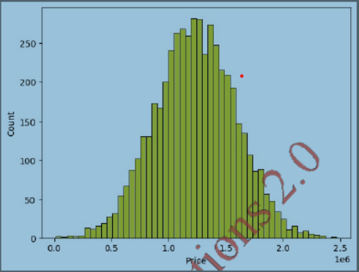

In [2]:

sns.boxplot(dataset, x='Price', palette='Blues')

Out[2]:

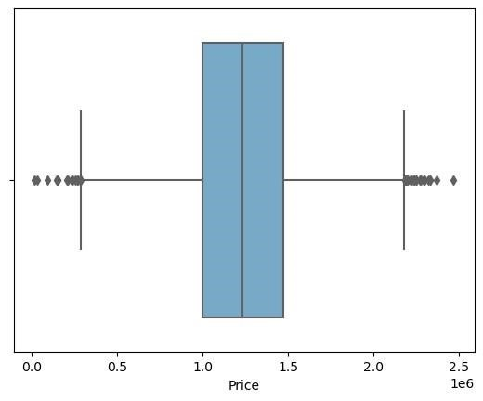<Axes: xlabel='Price'>

In [3]:

sns.jointplot(dataset, x='Avg. Area House Age', y='Price', kind='hex')

Out[3]:

<seaborn.axisgrid.JointGrid at 0x7caf1d571810>

In [4]:

sns.jointplot(dataset, x='Avg. Area Income', y='Price')

Out[4]:

<seaborn.axisgrid.JointGrid at 0x7caf1d8bf7f0>

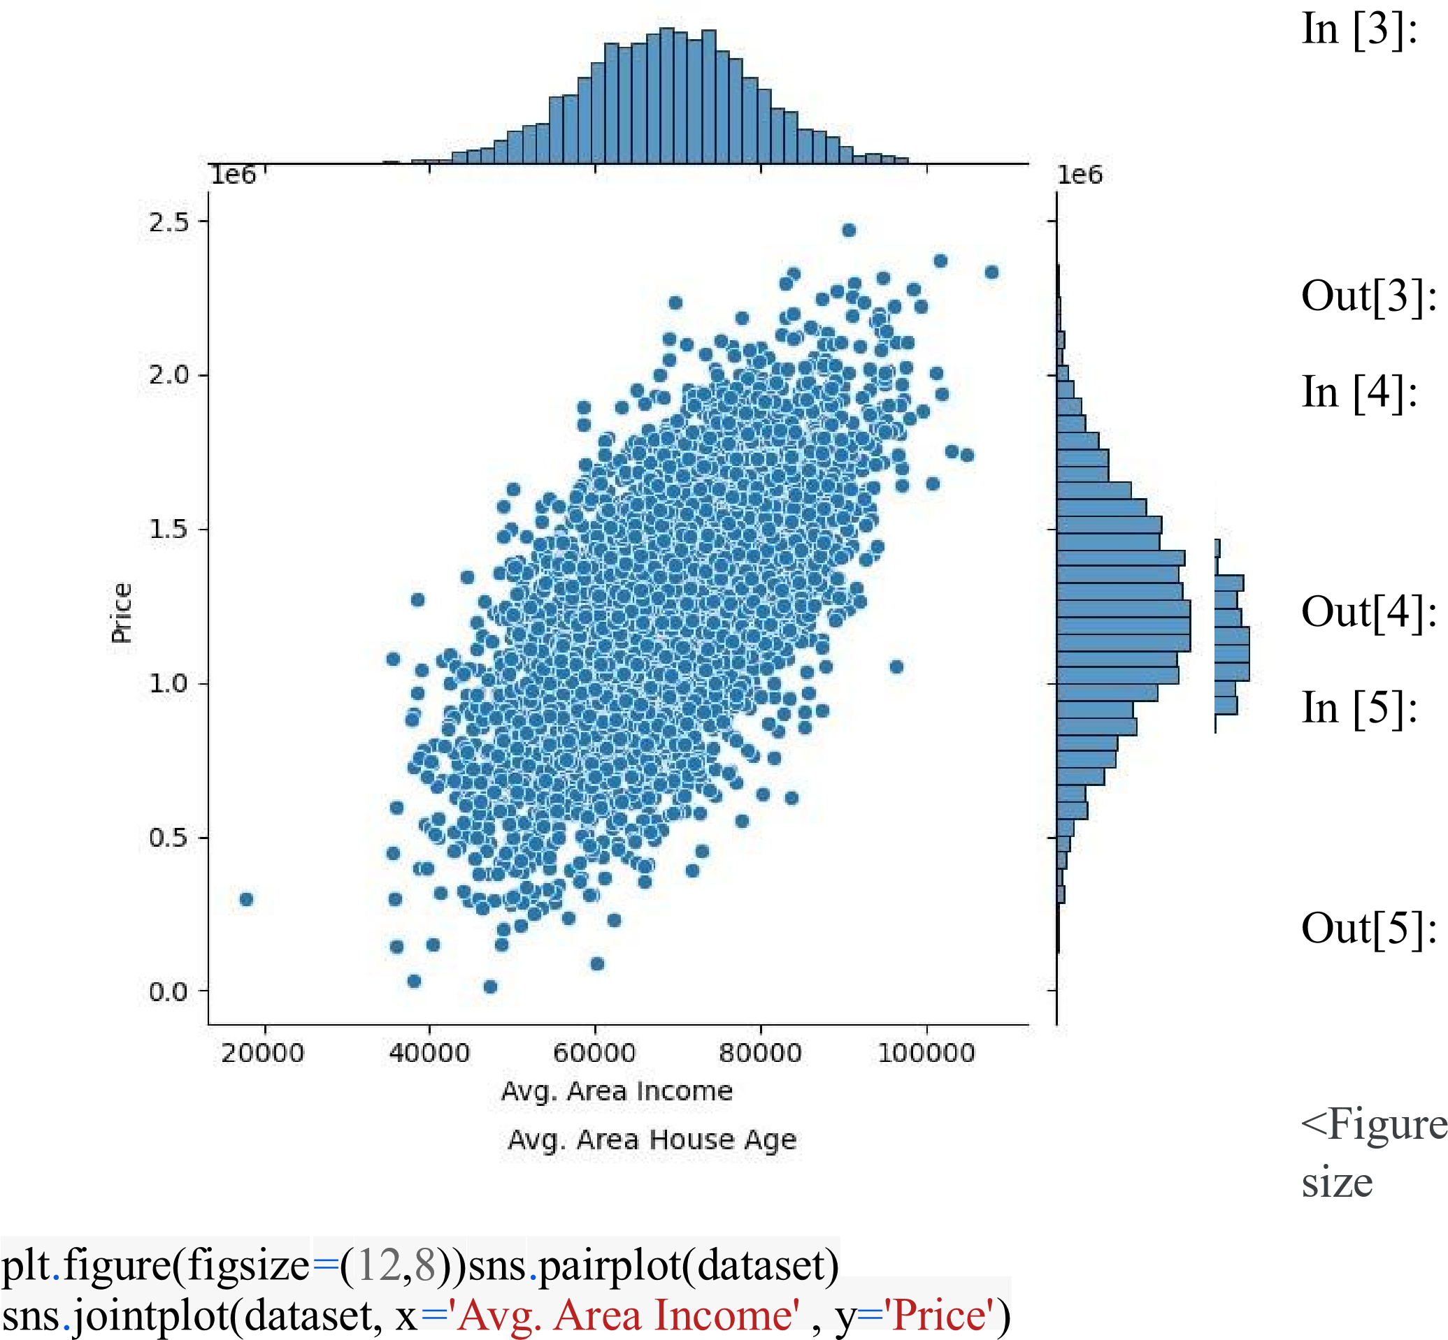

In [5]:

plt.figure(figsize=(12,8))sns.pairplot(dataset)

Out[5]:

<seaborn.axisgrid.PairGrid at 0x7caf0c2ac550>

<Figure size 1200x800 with 0 Axes>

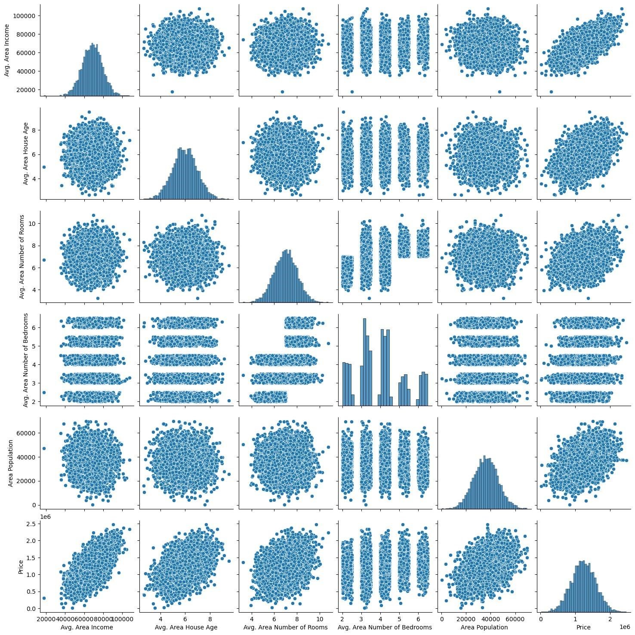

In [6]:

dataset.hist(figsize=(10,8))

Out[6]:

array([[<Axes: title={'center': 'Avg. Area Income'}>,

<Axes: title={'center': 'Avg. Area House Age'}>],

[<Axes: title={'center': 'Avg. Area Number of Rooms'}>,

<Axes: title={'center': 'Avg. Area Number of Bedrooms'}>],

[<Axes: title={'center': 'Area Population'}>,

<Axes: title={'center': 'Price'}>]], dtype=object)

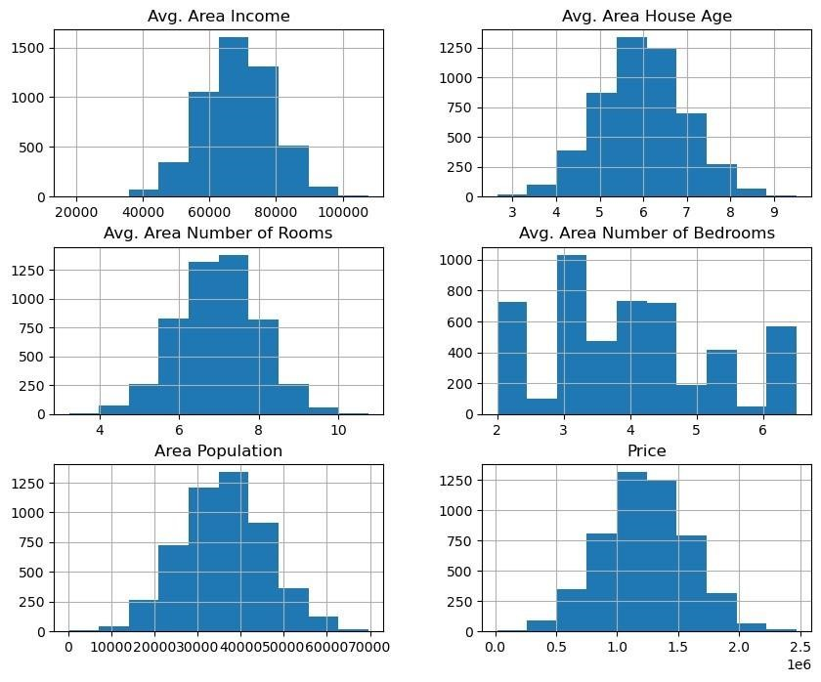

**Visualising Correlation:**

In [7]:

dataset.corr(numeric_only=True)

Out[7]:

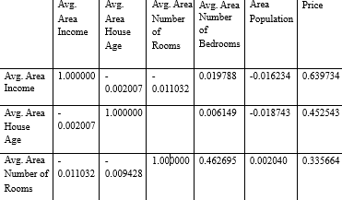

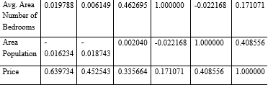

In [8]:

plt.figure(figsize=(10,5))sns.heatmap(dataset.corr(numeric_only = True), annot=True)

Out[8]:

<Axes: >

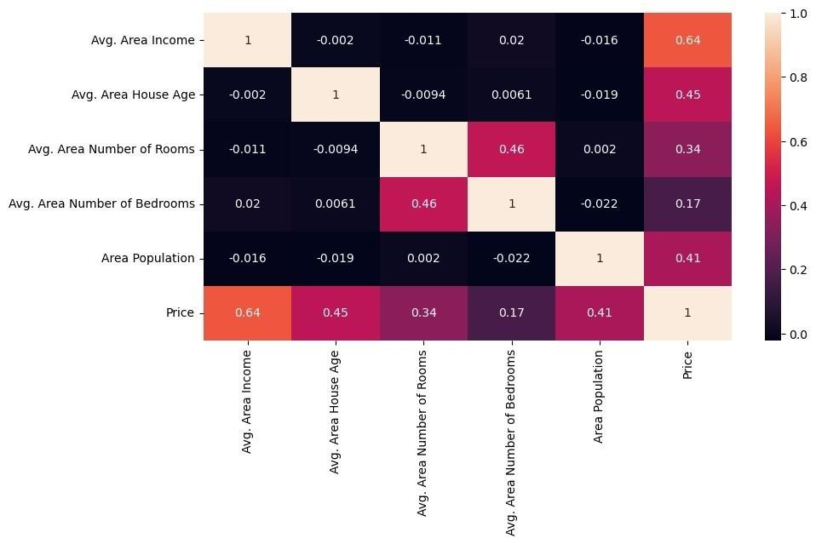

**3. Model Selection:**

Choose an appropriate machine learning model for your

regression task. Common choices include:

✓ Linear Regression

✓ Decision Trees

✓ Random Forest

✓ Gradient Boosting (e.g., XGBoost or LightGBM)

✓ Neural Networks (Deep Learning)

**Program:**

Importing Dependencies

import pandas as pd

import numpy as np

import seaborn as sns

import matplotlib.pyplot as plt

from sklearn.model_selection import train_test_split

from sklearn.preprocessing import StandardScaler

from sklearn.metrics import r2_score,

mean_absolute_error,mean_squared_error

from sklearn.linear_model import LinearRegression

from sklearn.linear_model import Lasso

from sklearn.ensemble import RandomForestRegressor

from sklearn.svm import SVR

import xgboost as xg

%matplotlib inline

import warnings

warnings.filterwarnings("ignore")

/opt/conda/lib/python3.10/site-packages/scipy/_init_.py:146:

UserWarning: A NumPy version >=1.16.5 and <1.23.0 is required

for this version of SciPy (detected version 1.23.5

warnings.warn(f"A NumPy version >={np_minversion} and

<{np_maxversion}"

**Loading Dataset**

dataset = pd.read_csv('E:/USA_Housing.csv')

**Model 1 - Linear Regression**

In [1]:

model_lr=LinearRegression()

In [2]:

model_lr.fit(X_train_scal, Y_train)

Out[2]:

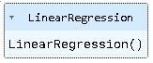

**Predicting Prices**

In [3]:

Prediction1 = model_lr.predict(X_test_scal)

**Evaluation of Predicted Data**

In [4]:

plt.figure(figsize=(12,6))

plt.plot(np.arange(len(Y_test)), Y_test, label='Actual Trend')

plt.plot(np.arange(len(Y_test)), Prediction1, label='Predicted Tr

end')

plt.xlabel('Data')

plt.ylabel('Trend')

plt.legend()

plt.title('Actual vs Predicted')

Out[4]:

Text(0.5, 1.0, 'Actual vs Predicted')

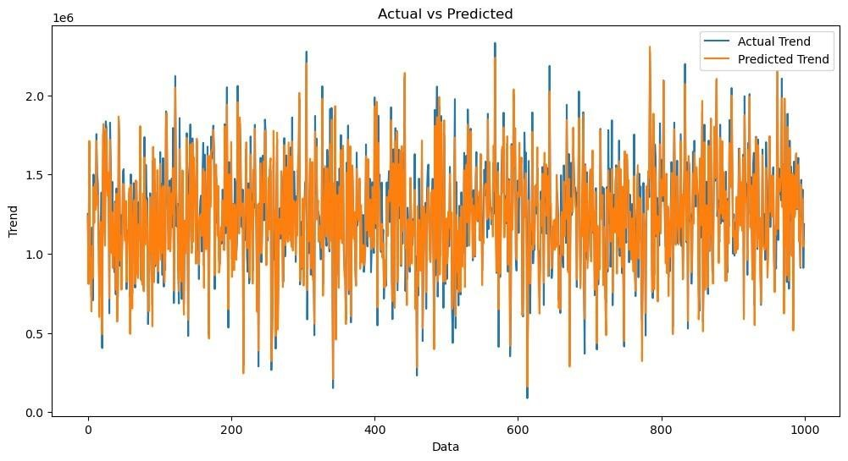

In [5]:

sns.histplot((Y_test-Prediction1), bins=50)

Out[5]:

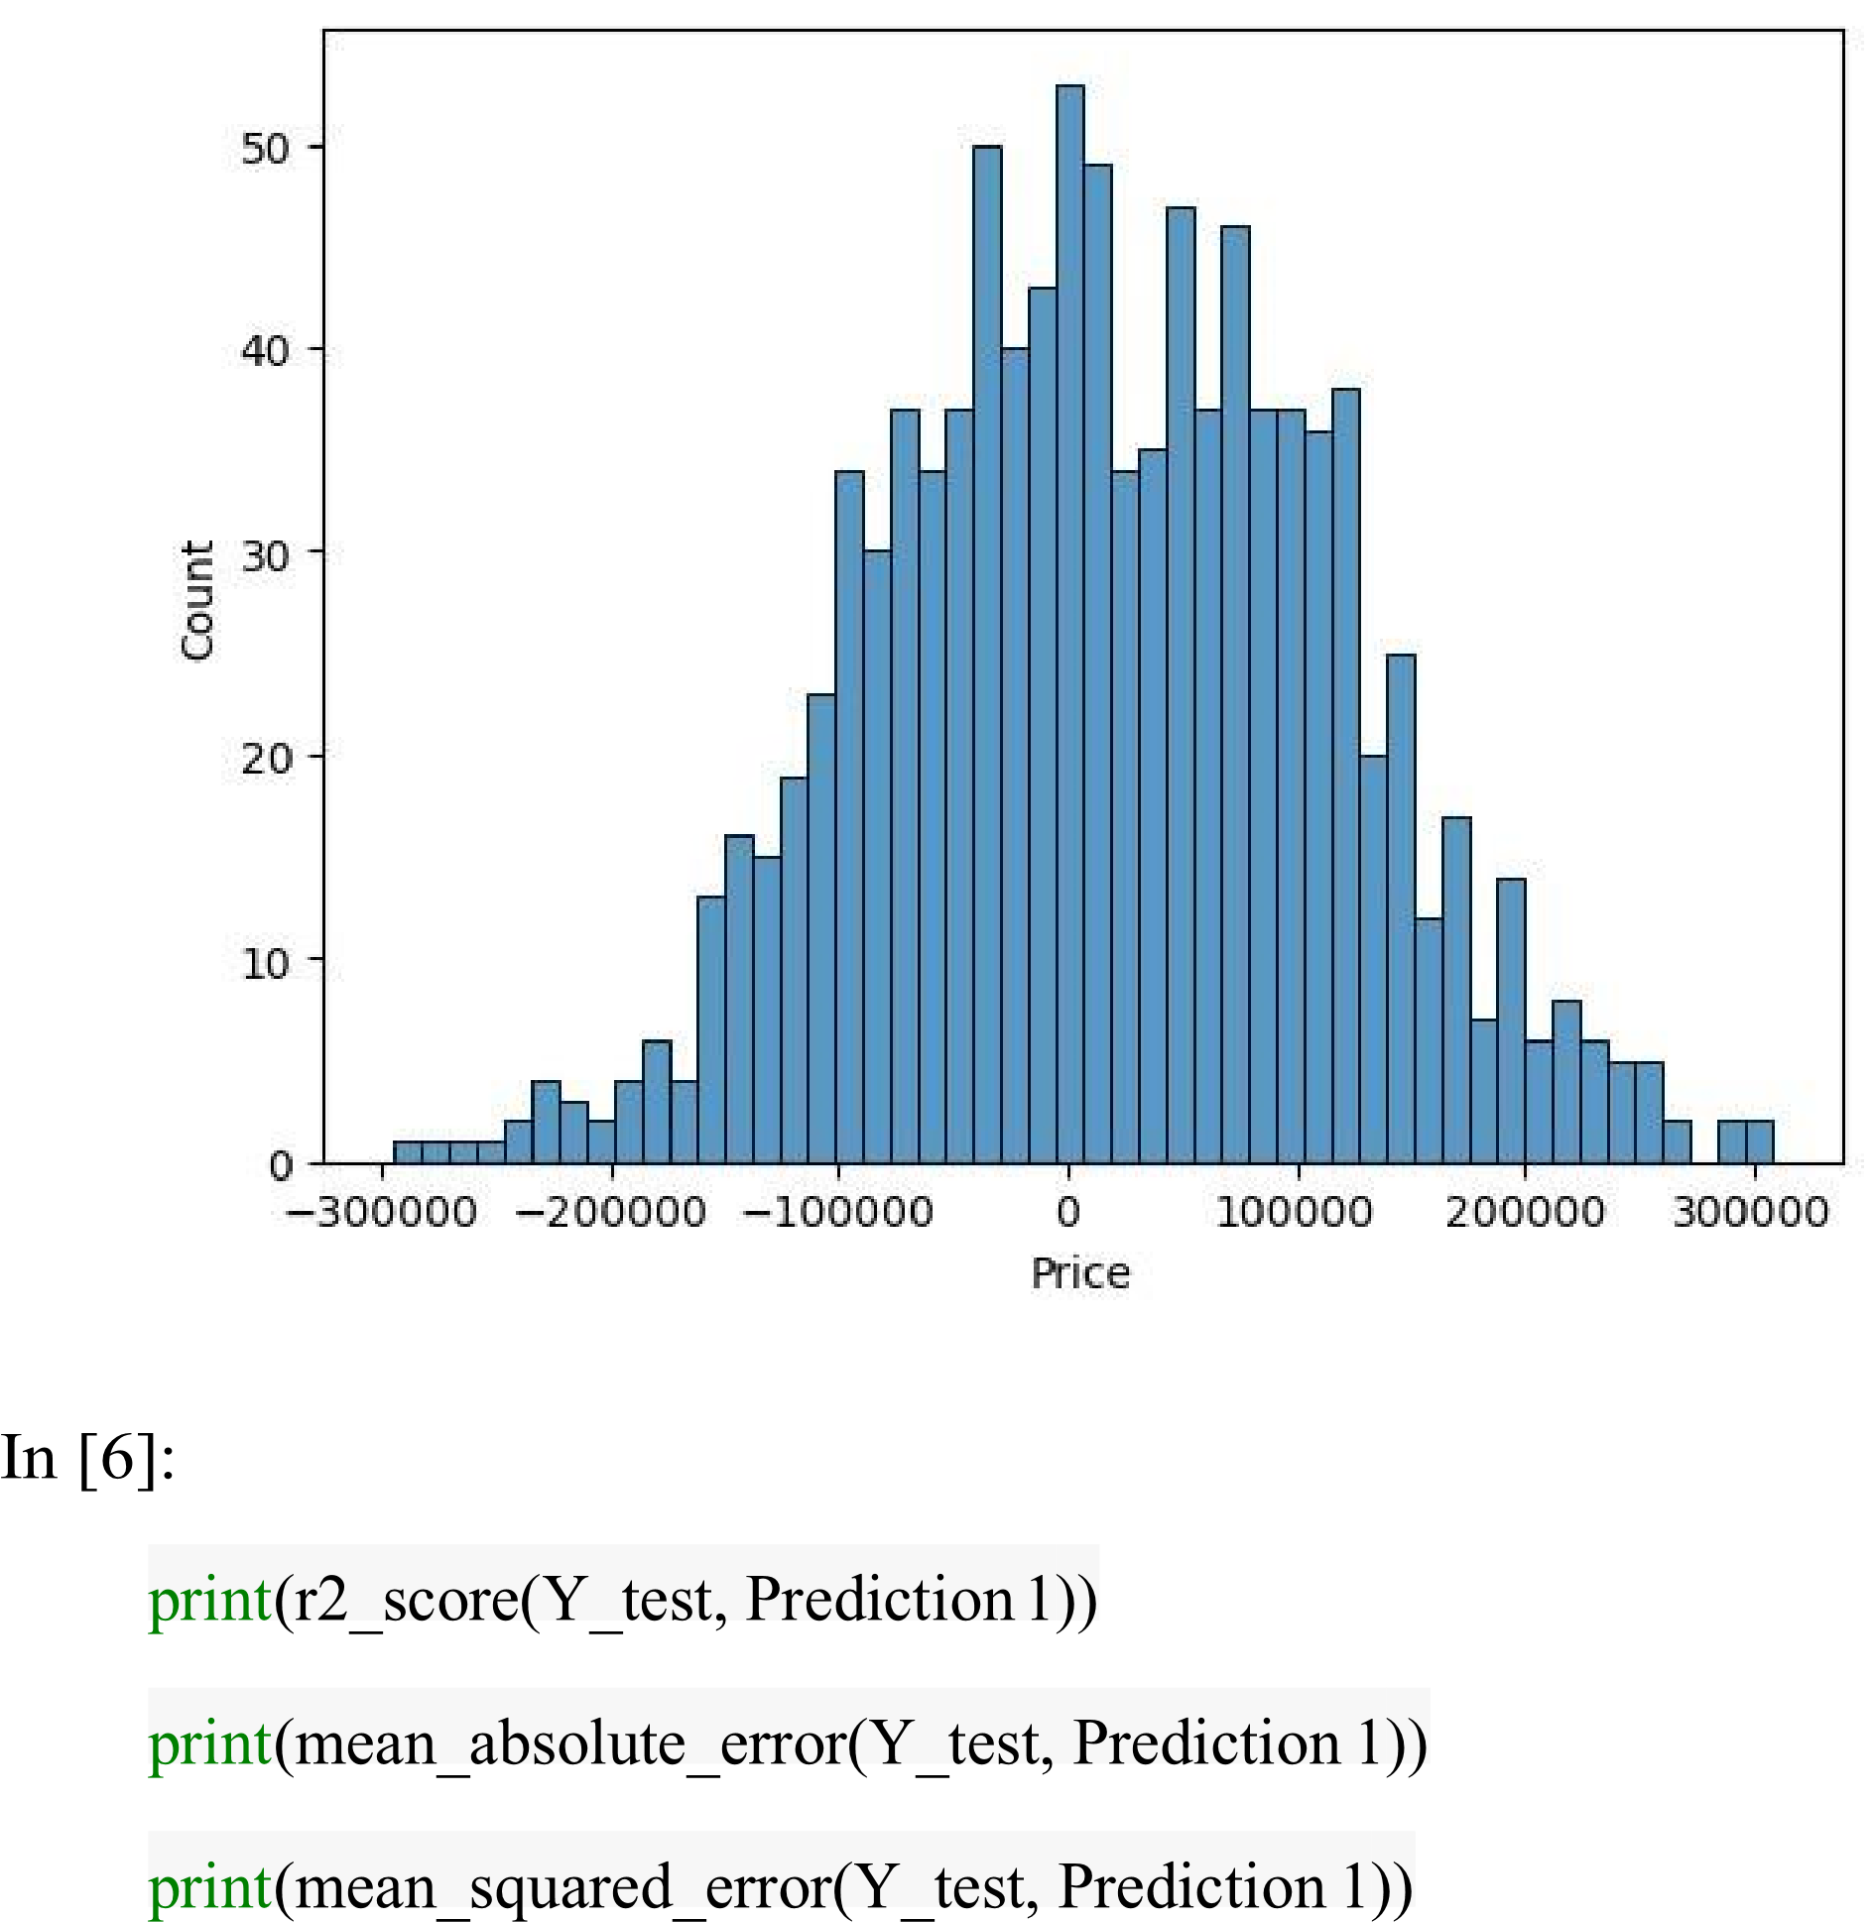<Axes: xlabel='Price', ylabel='Count'>

Out[6]:

0.9182928179392918

82295.49779231755

10469084772.975954

**Model 2 - Support Vector Regressor**

In [7]:

model_svr = SVR()

In [8]:

model_svr.fit(X_train_scal, Y_train)

Out[8]:



**Predicting Prices**

In [9]:

Prediction2 = model_svr.predict(X_test_scal)

**Evaluation of Predicted Data**

In [10]:

plt.figure(figsize=(12,6))

plt.plot(np.arange(len(Y_test)), Y_test, label='Actual Trend')

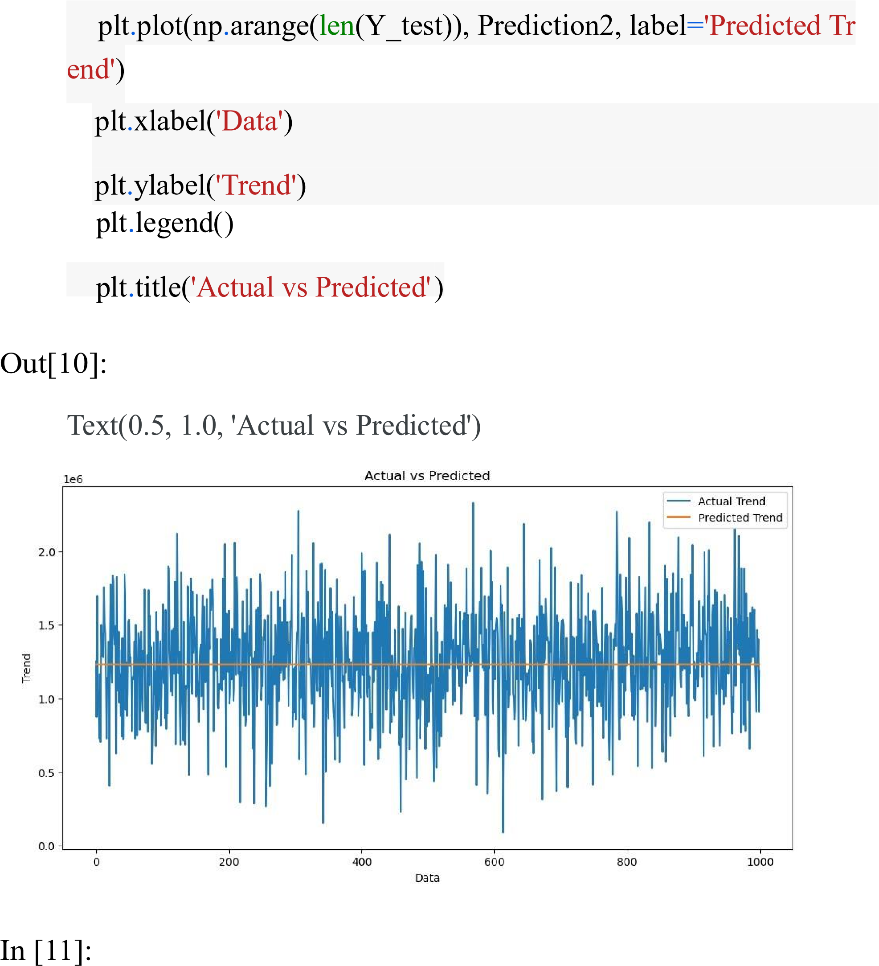

sns.histplot((Y_test-Prediction2), bins=50)

Out[12]:

<Axes: xlabel='Price', ylabel='Count'>

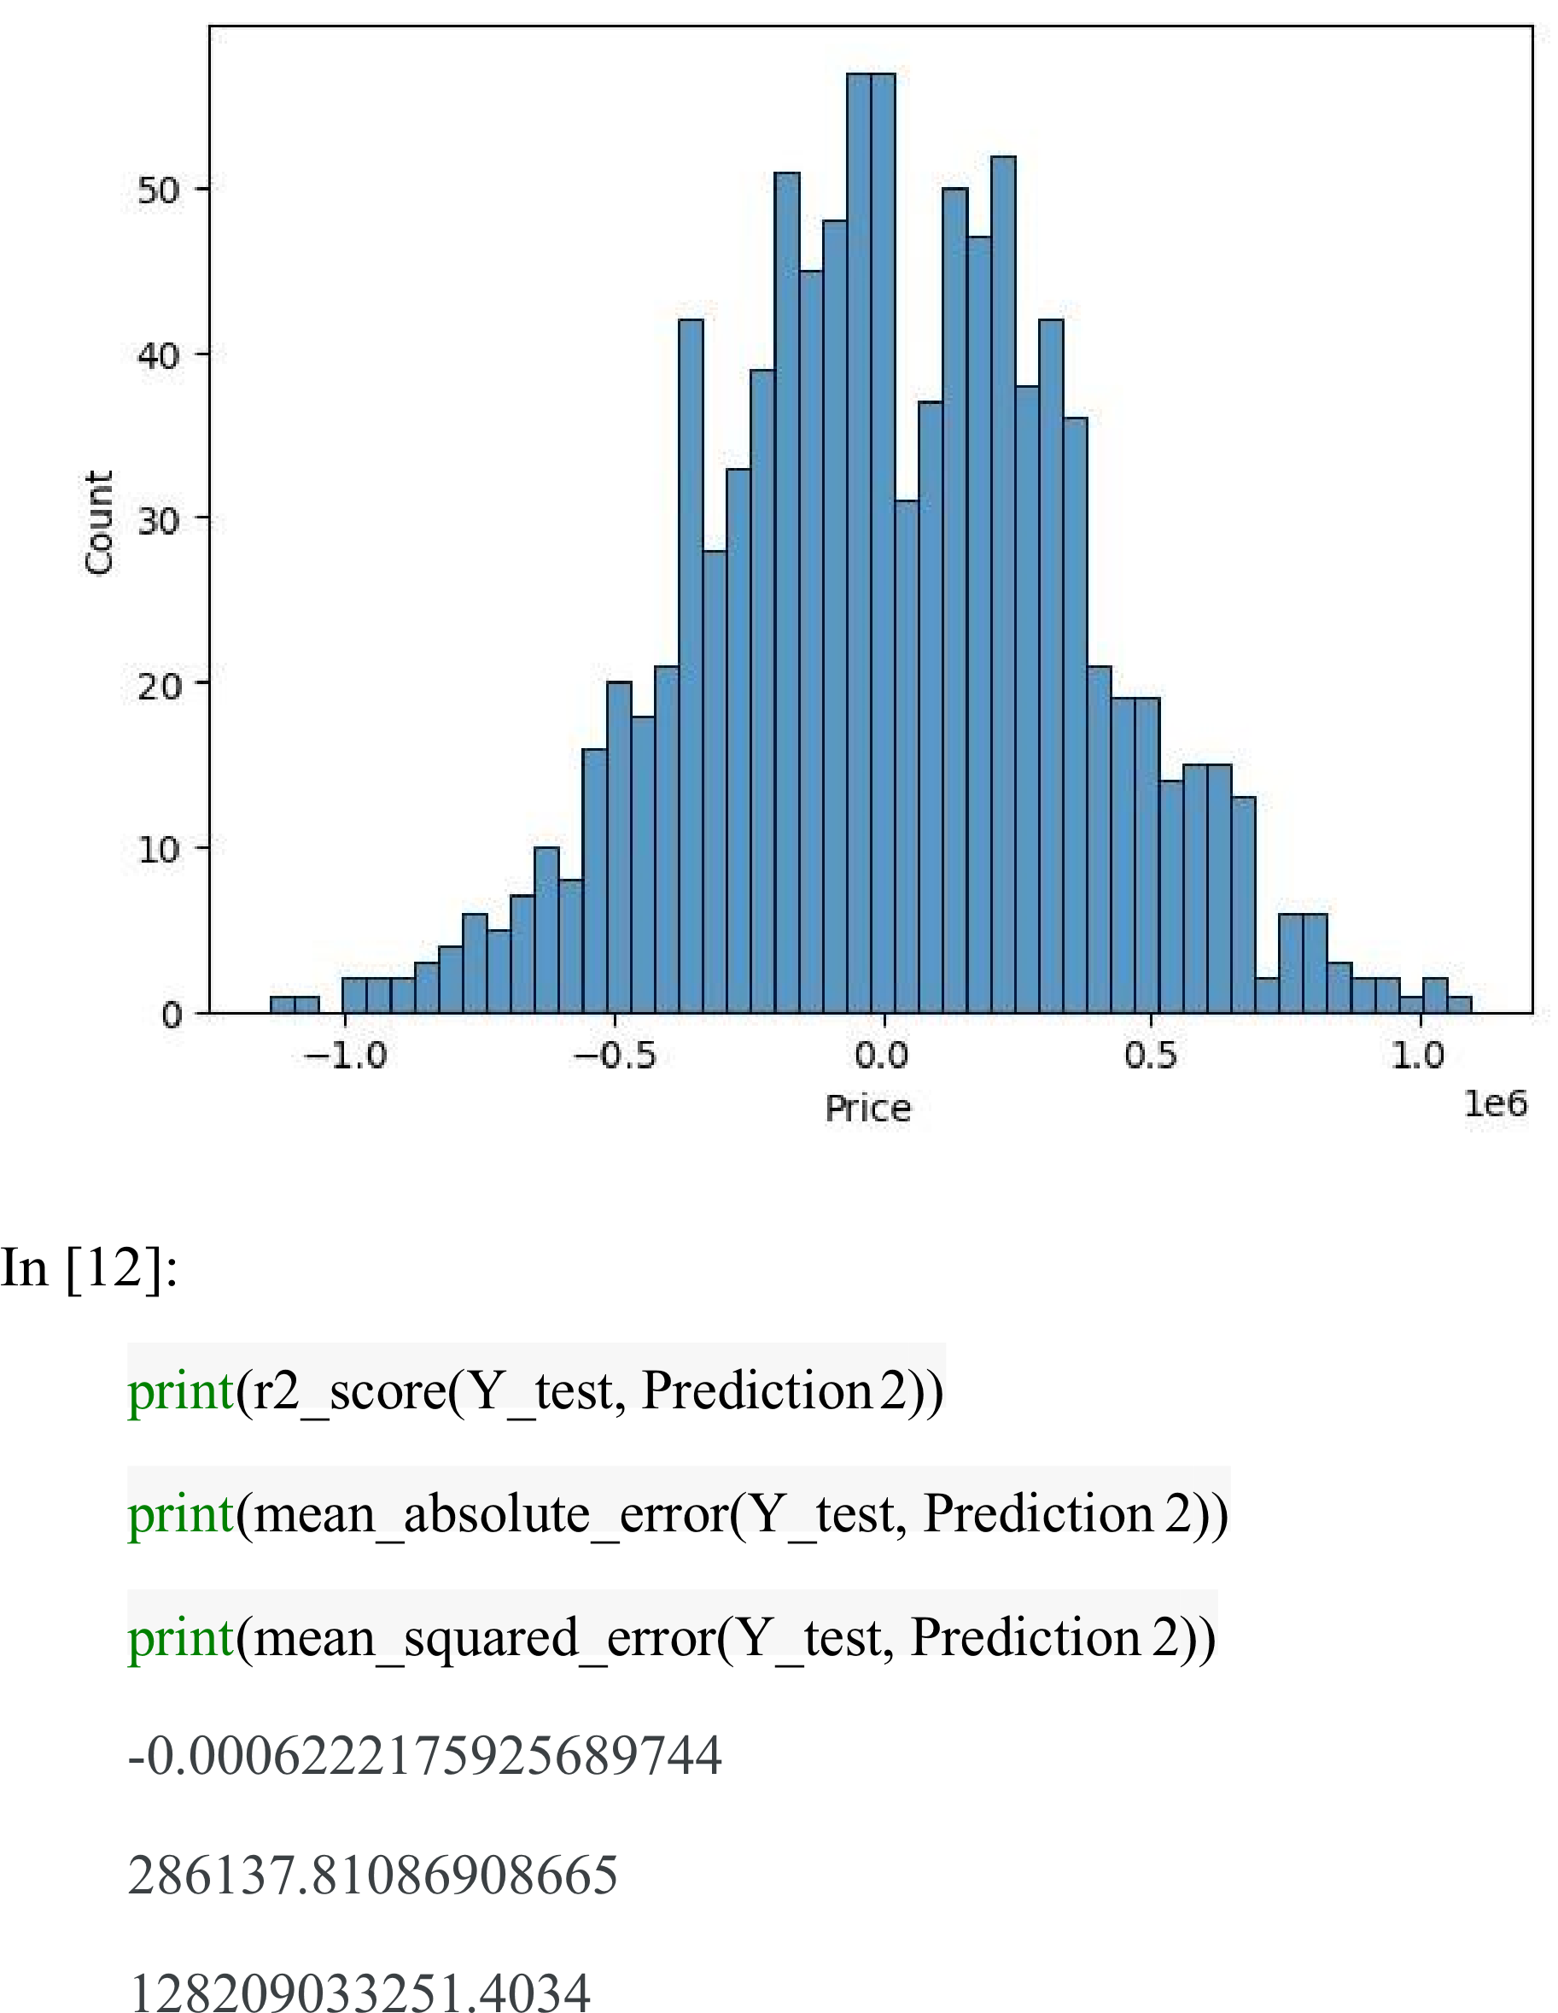

Model 3 - Lasso Regression

In [13]:

model_lar = Lasso(alpha=1)

In [14]:

model_lar.fit(X_train_scal,Y_train)

Out[14]:



Predicting Prices

In [15]:

Prediction3 = model_lar.predict(X_test_scal)

Evaluation of Predicted Data

In [16]:

plt.figure(figsize=(12,6))

plt.plot(np.arange(len(Y_test)), Y_test, label='Actual Trend')

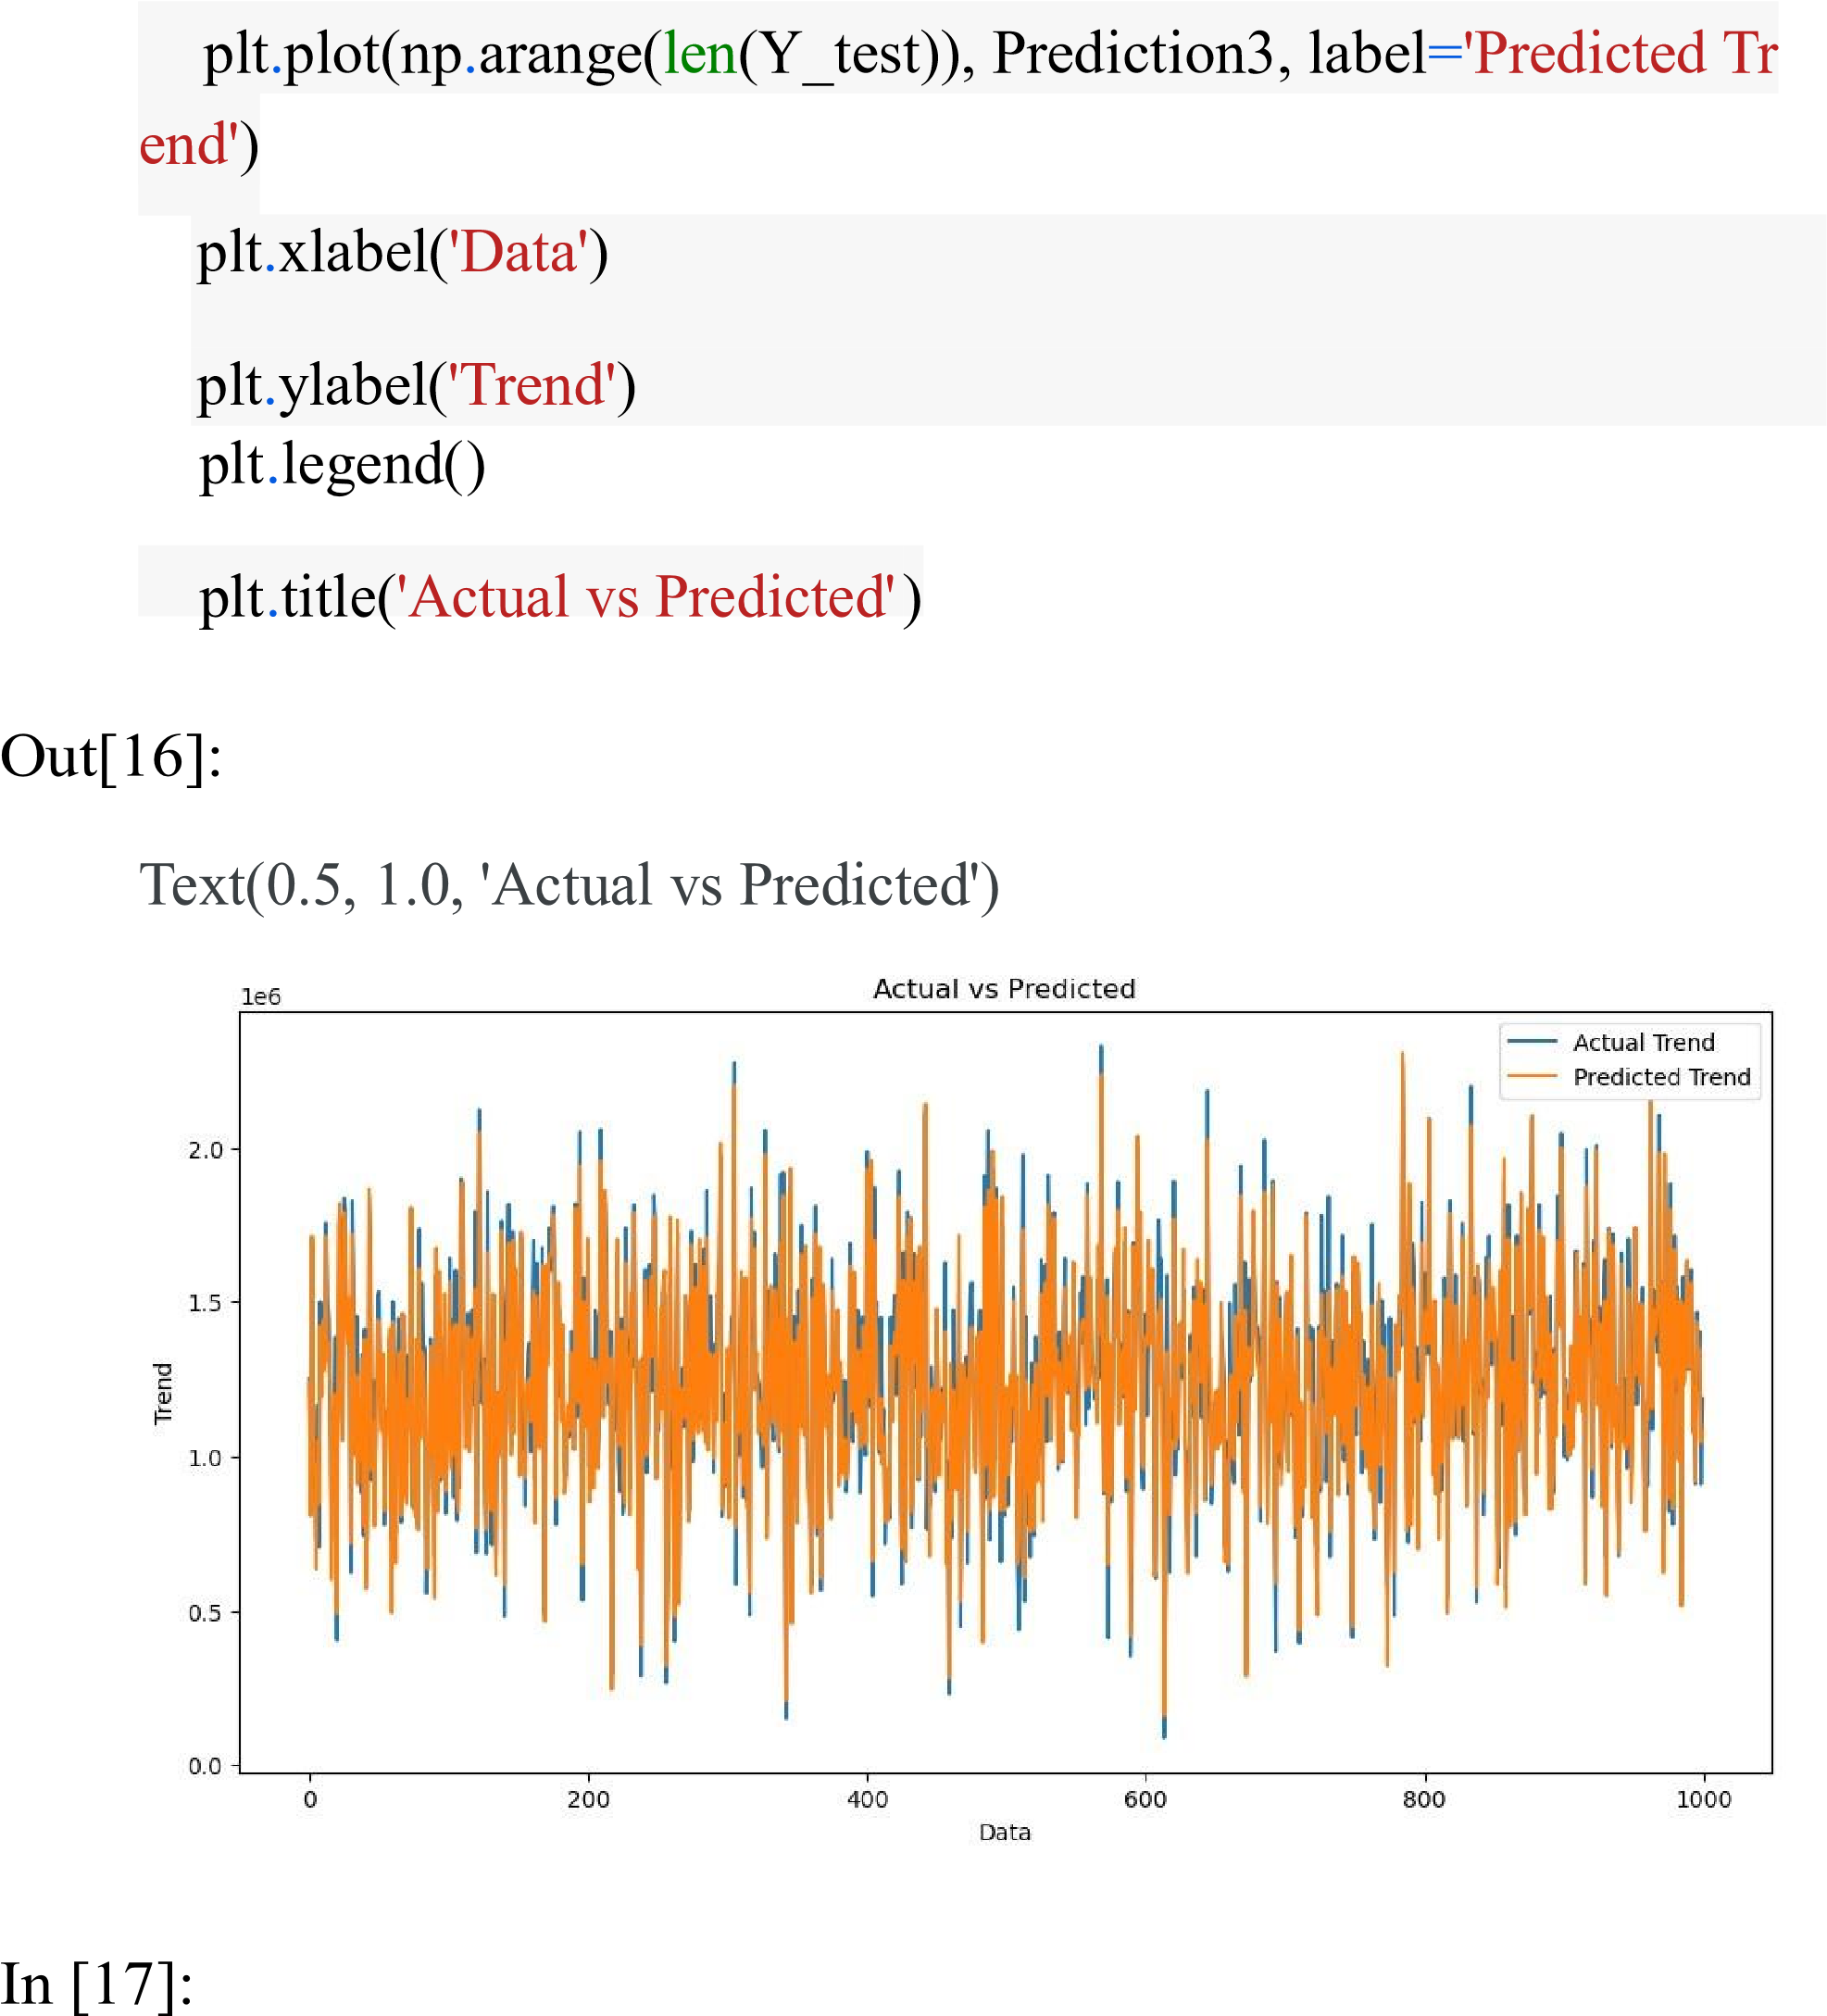

In [17]:

sns.histplot((Y_test-Prediction3), bins=50)

Out[17]:

<Axes: xlabel='Price', ylabel='Count'>

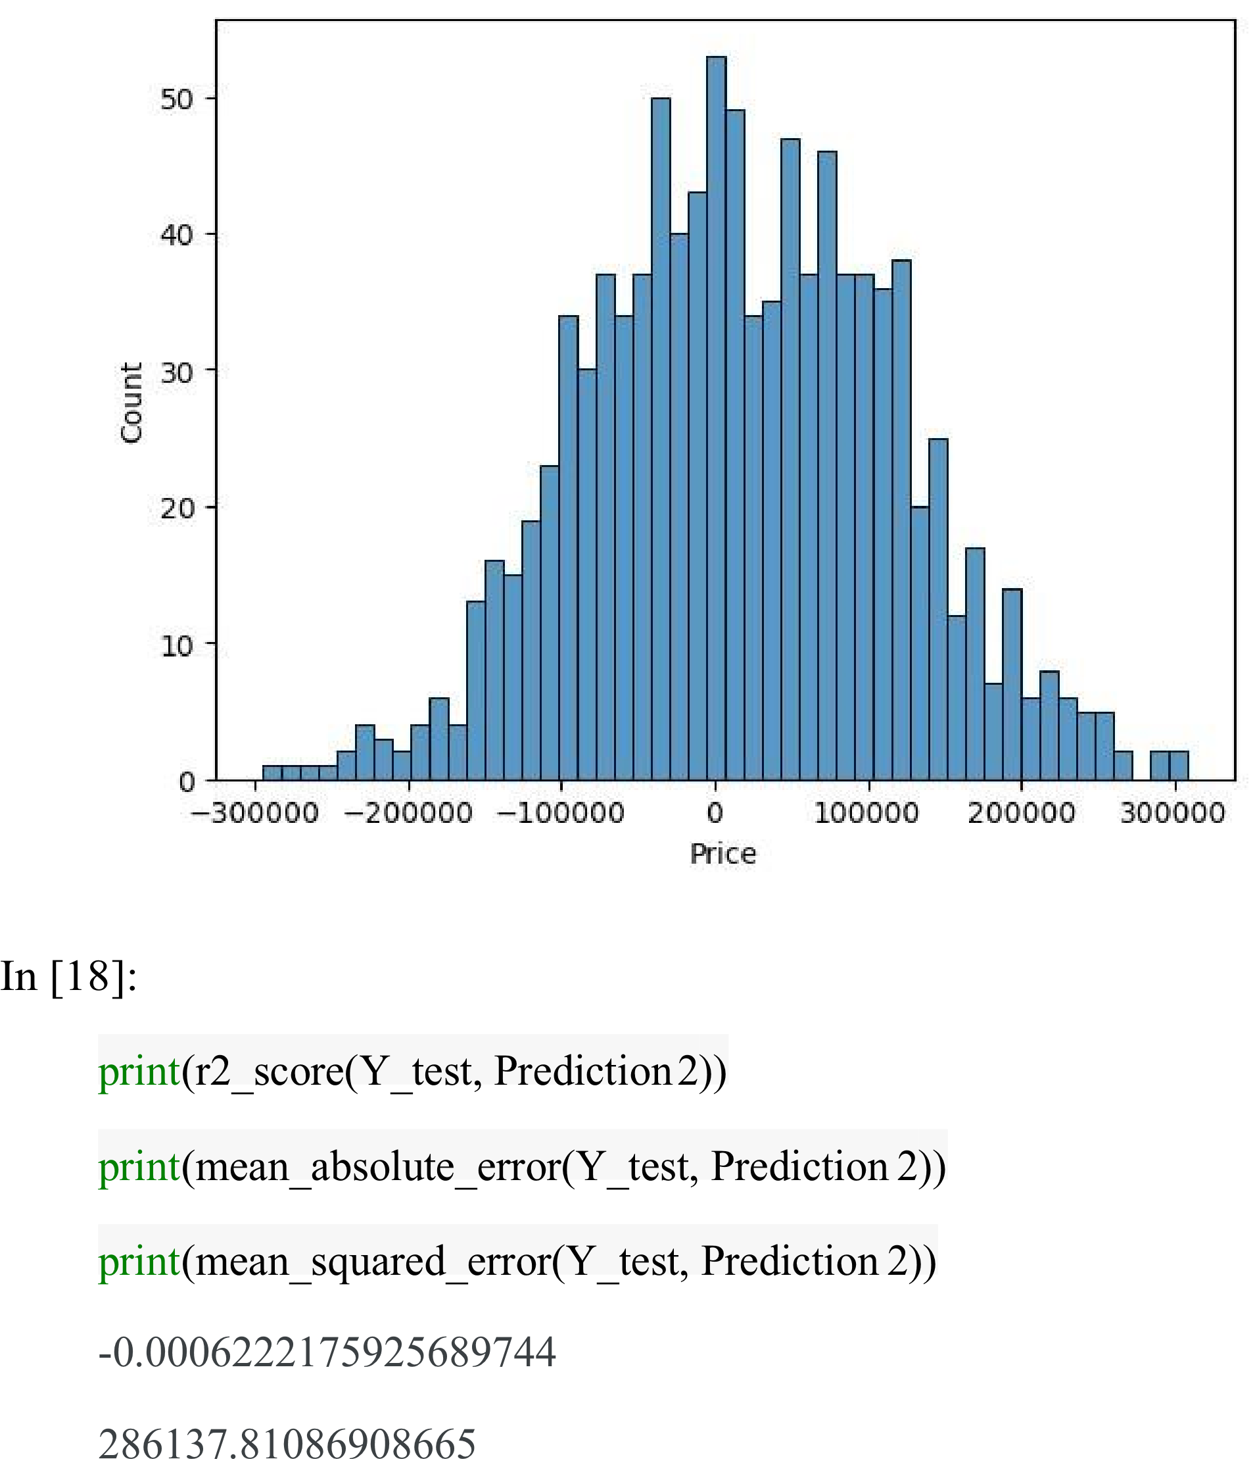

**Model 4 - Random Forest Regressor**

In [19]:

model_rf = RandomForestRegressor(n_estimators=50)

In [20]:

model_rf.fit(X_train_scal, Y_train)

Out[20]:



**Predicting Prices**

In [21]:

Prediction4 = model_rf.predict(X_test_scal)

**Model 5 - XGboost Regressor**

In [25]:

model_xg = xg.XGBRegressor()

In [26]:

model_xg.fit(X_train_scal, Y_train)

Out[26]:

**XGBRegressor**

XGBRegressor(base_score=None, booster=None,

callbacks=None,

colsample_bylevel=None, colsample_bynode=None,

colsample_bytree=None, early_stopping_rounds=None,

enable_categorical=False, eval_metric=None,

feature_types=None,

gamma=None, gpu_id=None, grow_policy=None,

importance_type=None,

interaction_constraints=None, learning_rate=None,

max_bin=None,

max_cat_threshold=None, max_cat_to_onehot=None,

max_delta_step=None, max_depth=None,

max_leaves=None,

min_child_weight=None, missing=nan,

monotone_constraints=None,

n_estimators=100, n_jobs=None,

num_parallel_tree=None,

predictor=None, random_state=None, ...)

**4. Model Training:**

Split your dataset into training and testing sets (as shown earlier)

and train the selected model on the training data. Here's an example

using Linear Regression:

5. Model Evaluation:

Evaluate your model's performance using appropriate regression

metrics, such as Mean Absolute Error (MAE), Mean Squared Error

(MSE), and Root Mean Squared Error (RMSE). For example:

**PYTHON PROGRAM:**

# Import necessary libraries

from sklearn.feature_selection import SelectKBest, f_regression

from sklearn.linear_model import LinearRegression

from sklearn.ensemble import RandomForestRegressor

from sklearn.metrics import mean_squared_error, r2_score

import numpy as np

selector = SelectKBest(score_func=f_regression, k=k)

X_train_selected = selector.fit_transform(X_train, y_train)

# Model Selection

# Let's choose both Linear Regression and Random Forest Regressor for comparison.

linear_reg_model = LinearRegression()

random_forest_model = RandomForestRegressor(n_estimators=100,

random_state=42)

# Train the models on the selected features

linear_reg_model.fit(X_train_selected, y_train)

random_forest_model.fit(X_train_selected, y_train)

# Evaluate the models on the test set

X_test_selected = selector.transform(X_test)

# Make predictions

linear_reg_predictions = linear_reg_model.predict(X_test_selected)

random_forest_predictions =

random_forest_model.predict(X_test_selected)

# Evaluate model performance

def evaluate_model(predictions, model_name):

mse = mean_squared_error(y_test, predictions)

r2 = r2_score(y_test, predictions)

print(f"{model_name} Model Evaluation:")

print(f"Mean Squared Error (MSE): {mse}")

print(f"R-squared (R2) Score: {r2}\n")

# Performance Measure

elr_mse = mean_squared_error(y_test, pred)

elr_rmse = np.sqrt(lr_mse)

elr_r2 = r2_score(y_test, pred)

# Show Measures

result = '''

MSE : {}

RMSE : {}

R^2 : {}

'''.format(lr_mse, lr_rmse, lr_r2)

print(result)

# Model Comparision

names.append("elr")

mses.append(elr_mse)

rmses.append(elr_rmse)

r2s.append(elr_r2)

evaluate_model(linear_reg_predictions, "Linear Regression")

evaluate_model(random_forest_predictions, "Random Forest Regressor")

**OUTPUT:**

Linear Regression Model Evaluation:

Mean Squared Error (MSE): 10089009300.893988

R-squared (R2) Score: 0.9179971706834331

Random Forest Regressor Model Evaluation:

Mean Squared Error (MSE): 14463028828.265167

R-squared (R2) Score: 0.8824454166872736

MSE : 10141766848.330585

RMSE : 100706.33966305491

R^2 : 0.913302484308253

**Model Comparison:**

The less the Root Mean Squared Error (RMSE), The better the

model is.

In [30]:

models.sort_values(by="RMSE (Cross-Validation)")

Out[30]:

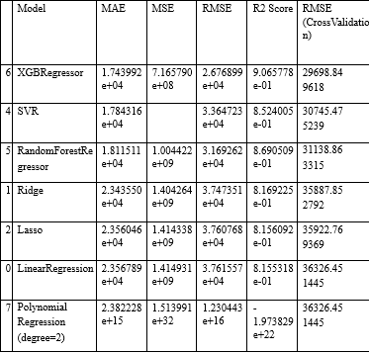

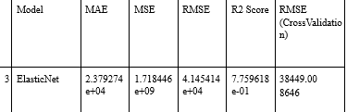

In [31]:

plt.figure(figsize=(12,8))

sns.barplot(x=models["Model"], y=models["RMSE (Cross-Validation)

"])

plt.title("Models' RMSE Scores (Cross-Validated)", size=15)

plt.xticks(rotation=30, size=12)

plt.show()

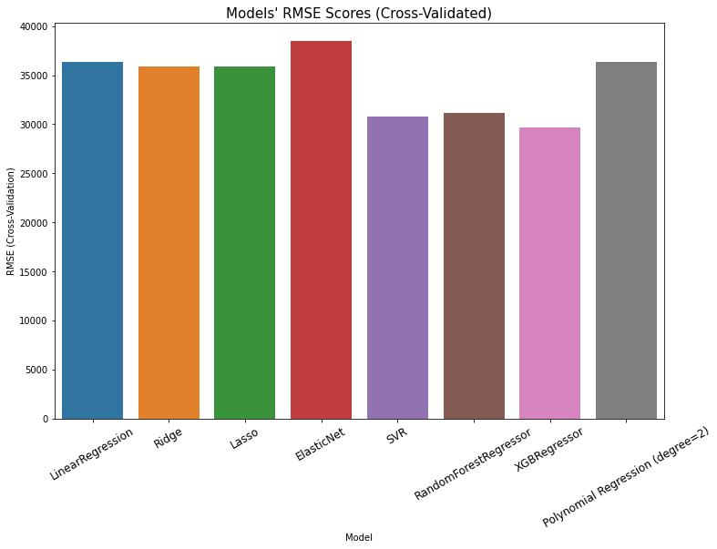

**Evaluation of Predicted Data**

In [22]:

plt.figure(figsize=(12,6))

plt.plot(np.arange(len(Y_test)), Y_test, label='Actual Trend')

plt.plot(np.arange(len(Y_test)), Prediction4, label='Predicted Tr

end')

plt.xlabel('Data')

plt.ylabel('Trend')

plt.legend()

plt.title('Actual vs Predicted')

Out[22]:

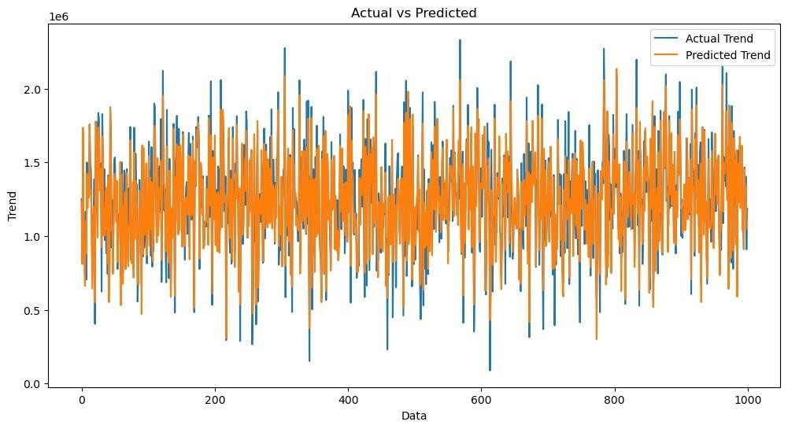

In [23]:

sns.histplot((Y_test-Prediction4), bins=50)

Out[23]:

<Axes: xlabel='Price', ylabel='Count'>

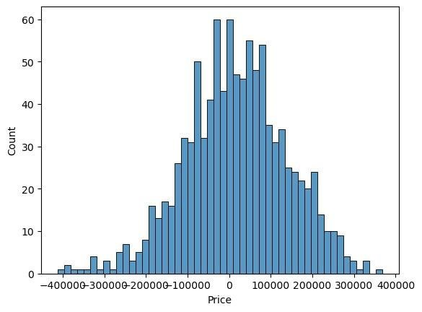

In [24]:

print(r2_score(Y_test, Prediction2))

print(mean_absolute_error(Y_test, Prediction2))

print(mean_squared_error(Y_test, Prediction2))

Out [24] :

-0.0006222175925689744

286137.81086908665

128209033251.4034

**6. Hyperparameter Tuning:**

Optimize the model's hyperparameters to improve its

performance. Depending on the model, you can use techniques like gridsearch or random search.

**7. Cross-Validation:**

Implement cross-validation to ensure that your model's

performance is consistent across different subsets of your data. This

helps prevent overfitting.

**8. Regularization:**

Apply regularization techniques like L1 (Lasso) or L2 (Ridge)

if needed to prevent overfitting and improve model generalization.

**Feature Selection:**

Use feature importance scores from your model or techniques

like recursive feature elimination to identify the most important features for predictions.

Interpretability:

Ensure that the model's predictions are interpretable and

explainable. Stakeholders may want to understand how each feature

impacts the predicted house price.

Deployment:

Deploy your trained model in a real-world setting, whether it's

through a web application, API, or any other user-friendly interface.

Users can input property details, and the model provides price

predictions.

Monitoring and Maintenance:

Continuously monitor the model's performance and update it as

needed. Real estate markets change, so it's essential to retrain the model with new data periodically.

Ethical Considerations:

Ensure that your model doesn't introduce or perpetuate biases

in pricing. Implement fairness and transparency measures.

Innovation:

Explore innovative approaches such as incorporating external

data sources (e.g., satellite imagery, IoT data) for better predictions.

**PROJECT LINK:**

[**https://colab.research.google.com/drive/11gr0u5dBlHlV_ml9Fk8iLKo1WROObMdI?usp=sharing**](https://colab.research.google.com/drive/11gr0u5dBlHlV_ml9Fk8iLKo1WROObMdI?usp=sharing)

**SOURCE CODE**

import pandas as pd

from sklearn.preprocessing import LabelEncoder

from sklearn.model_selection import train_test_split

from sklearn.impute import SimpleImputer

from sklearn.preprocessing import StandardScaler

data = pd.read_csv('/content/USA_Housing.csv')

print("Dataset Preview:")

print(data.head())

numeric_cols = data.select_dtypes(include='number').columns

categorical_cols = data.select_dtypes(exclude='number').columns

imputer_numeric = SimpleImputer(strategy='mean')

imputer_categorical = SimpleImputer(strategy='most_frequent')

data[numeric_cols] =imputer_numeric.fit_transform(data[numeric_cols])

data[categorical_cols] =imputer_categorical.fit_transform(data[categorical_cols])

label_encoder = LabelEncoder()

for col in categorical_cols:

data[col] = label_encoder.fit_transform(data[col])

X = data.drop(columns=['Price'])

y = data['Price']

scaler = StandardScaler()

X_scaled = scaler.fit_transform(X)

X_train, X_test, y_train, y_test = train_test_split(X_scaled, y,

test_size=0.2, random_state=42)

print("\nPreprocessed Data:")

print(X_train[:5])

print(y_train[:5])

# Commented out IPython magic to ensure Python compatibility.

import pandas as pd

import numpy as np

import seaborn as sns

import matplotlib.pyplot as plt

from sklearn.model_selection import train_test_split

from sklearn.preprocessing import StandardScaler

from sklearn.metrics import r2_score,mean_absolute_error,mean_squared_error

from sklearn.linear_model import LinearRegression

from sklearn.linear_model import Lasso

from sklearn.ensemble import RandomForestRegressor

from sklearn.svm import SVR

import xgboost as xg

# %matplotlib inline

import warnings

warnings.filterwarnings("ignore")

dataset = pd.read_csv('/content/USA_Housing.csv')

dataset.columns

print("Missing Values by Column")

print("-"*30)

print(df.isna().sum())

print("-"*30)

print("TOTAL MISSING VALUES:",df.isna().sum().sum())

sns.histplot(dataset, x='Price', bins=50, color='y')

sns.boxplot(dataset, x='Price', palette='Blues')

sns.jointplot(dataset, x='Avg. Area House Age', y='Price', kind='hex')

sns.jointplot(dataset, x='Avg. Area Income', y='Price')

plt.figure(figsize=(12,8))

sns.pairplot(dataset)

dataset.hist(figsize=(10,8))

dataset.corr(numeric_only=True)

plt.figure(figsize=(10,5))

sns.heatmap(dataset.corr(numeric_only = True), annot=True)

# Commented out IPython magic to ensure Python compatibility.

import pandas as pd

import numpy as np

import seaborn as sns

import matplotlib.pyplot as plt

from sklearn.model_selection import train_test_split

from sklearn.preprocessing import StandardScaler

from sklearn.metrics import r2_score,mean_absolute_error,mean_squared_error

from sklearn.linear_model import LinearRegression

from sklearn.linear_model import Lasso

from sklearn.ensemble import RandomForestRegressor

from sklearn.svm import SVR

import xgboost as xg

# %matplotlib inline

import warnings

warnings.filterwarnings("ignore")

dataset = pd.read_csv('/content/USA_Housing.csv')

model_lr=LinearRegression()

model_lr.fit(X_train, y_train)

Prediction1 = model_lr.predict(X_test)

plt.figure(figsize=(12,6))

plt.plot(np.arange(len(y_test)),y_test, label='Actual Trend')

plt.plot(np.arange(len(y_test)), Prediction1, label='Predicted Trend')

plt.xlabel('Data')

plt.ylabel('Trend')

plt.legend()

plt.title('Actual vs Predicted')

sns.histplot((y_test-Prediction1), bins=50)

print(r2_score(y_test, Prediction1))

print(mean_absolute_error(y_test, Prediction1))

print(mean_squared_error(y_test, Prediction1))

model_svr = SVR()

model_svr.fit(X_train, y_train)

Prediction2 = model_svr.predict(X_test)

plt.figure(figsize=(12,6))

plt.plot(np.arange(len(y_test)), y_test, label='Actual Trend')

plt.plot(np.arange(len(y_test)), Prediction2, label='Predicted Trend')

plt.xlabel('Data')

plt.ylabel('Trend')

plt.legend()

plt.title('Actual vs Predicted')

sns.histplot((y_test-Prediction2), bins=50)

print(r2_score(y_test, Prediction2))

print(mean_absolute_error(y_test, Prediction2))

print(mean_squared_error(y_test, Prediction2))

model_lar = Lasso(alpha=1)

model_lar.fit(X_train,y_train)

Prediction3 = model_lar.predict(X_test)

plt.figure(figsize=(12,6))

plt.plot(np.arange(len(y_test)), y_test, label='Actual Trend')

plt.plot(np.arange(len(y_test)), Prediction3, label='Predicted Trend')

plt.xlabel('Data')

plt.ylabel('Trend')

plt.legend()

plt.title('Actual vs Predicted')

sns.histplot((y_test-Prediction3), bins=50)

print(r2_score(y_test, Prediction2))

print(mean_absolute_error(y_test, Prediction2))

print(mean_squared_error(y_test, Prediction2))

model_rf = RandomForestRegressor(n_estimators=50)

model_rf.fit(X_train, y_train)

Prediction4 = model_rf.predict(X_test)

model_xg = xg.XGBRegressor()

model_xg.fit(X_train, y_train)

from sklearn.feature_selection import SelectKBest, f_regression

from sklearn.linear_model import LinearRegression

from sklearn.ensemble import RandomForestRegressor

from sklearn.metrics import mean_squared_error, r2_score

import numpy as np

linear_reg_model.fit(X_train, y_train)

random_forest_model.fit(X_train,y_train)

from sklearn.feature_selection import SelectKBest, f_regression

from sklearn.linear_model import LinearRegression

from sklearn.ensemble import RandomForestRegressor

from sklearn.metrics import mean_squared_error, r2_score

import numpy as np

# Assuming you have X_train, X_test, y_train, and y_test defined

# Feature Selection

# You should specify the number of top features you want to select

selector = SelectKBest(score_func=f_regression, k=k)

X_train_selected = selector.fit_transform(X_train, y_train)

X_test_selected = selector.transform(X_test)

# Model Selection

linear_reg_model = LinearRegression()

random_forest_model = RandomForestRegressor(n_estimators=100, random_state=42)

# Train the models on the selected features

linear_reg_model.fit(X_train_selected, y_train)

random_forest_model.fit(X_train_selected, y_train)

# Make predictions

linear_reg_predictions = linear_reg_model.predict(X_test_selected)

random_forest_predictions = random_forest_model.predict(X_test_selected)

# Evaluate model performance

def evaluate_model(predictions, model_name):

mse = mean_squared_error(y_test, predictions)

r2 = r2_score(y_test, predictions)

print(f"{model_name} Model Evaluation:")

print(f"Mean Squared Error (MSE): {mse}")

print(f"R-squared (R2) Score: {r2}\n")

# Model Comparison

evaluate_model(linear_reg_predictions, "Linear Regression")

evaluate_model(random_forest_predictions, "Random Forest Regressor")

# Performance Measure for Linear Regression

lr_mse = mean_squared_error(y_test, linear_reg_predictions)

lr_rmse = np.sqrt(lr_mse)

lr_r2 = r2_score(y_test, linear_reg_predictions)

# Show Measures

result = f'''

MSE : {lr_mse}

RMSE : {lr_rmse}

R^2 : {lr_r2}

'''

print(result)

models.sort_values(by="RMSE (Cross-Validation)")

plt.figure(figsize=(12,8))

sns.barplot(x=models["Model"], y=models["RMSE (Cross-Validation)"])

plt.title("Models' RMSE Scores (Cross-Validated)", size=15)

plt.xticks(rotation=30, size=12)

plt.show()

plt.figure(figsize=(12,6))

plt.plot(np.arange(len(y_test)), y_test, label='Actual Trend')

plt.plot(np.arange(len(y_test)), Prediction4, label='Predicted Trend')

plt.xlabel('Data')

plt.ylabel('Trend')

plt.legend()

plt.title('Actual vs Predicted')

sns.histplot((y_test-Prediction4), bins=50)

print(r2_score(y_test, Prediction2))

print(mean_absolute_error(y_test, Prediction2))

print(mean_squared_error(y_test, Prediction2))

CONCLUSION:

Predicting house prices using machine learning is a transformative and promising approach that has the potential to revolutionize the real estate industry. Throughout this exploration, we have uncovered the remarkable capabilities of machine learning in providing more accurate, data-driven, and nuanced predictions for property values. As we conclude, several key takeaways and implications emerge:

Improved Accuracy: Machine learning models consider a myriad of variables, many of which may be overlooked by traditional methods. This results in more accurate predictions, benefiting both buyers and sellers who can make informed decisions based on a property's true value.

Data-Driven Insights: These models provide valuable insights into the real estate market by identifying trends, neighborhood characteristics, and other factors that influence property prices. This information can be invaluable for investors, developers, and policymakers seeking to make strategic decisions.

Market Efficiency: The increased accuracy in pricing predictions can lead to a more efficient real estate market, reducing overvaluation and undervaluation of properties. This contributes to a fairer and more transparent marketplace.

Challenges and Considerations: Machine learning for house price prediction is not without its challenges. Data quality, model interpretability, and ethical concerns are important considerations. Addressing these issues is crucial for the responsible and ethical deployment of this technology.

Continual Advancement: The field of machine learning is continually evolving, and as it does, so will the accuracy and capabilities of predictive models. As more data becomes available and algorithms improve, we can expect even more sophisticated predictions in the future.

### In conclusion, the application of machine learning in

predicting house prices is a groundbreaking development with farreaching implications. It empowers individuals, businesses, and governments to navigate the real estate market with more confidence and precision. However, it is essential to approach this technology with a clear understanding of its potential and limitations, ensuring that its benefits are harnessed responsibly for the betterment of the real estate industry and society as a whole. As machine learning continues to advance, we can look forward to a future where property valuation becomes increasingly precise and data-informed.